QUESTION 1
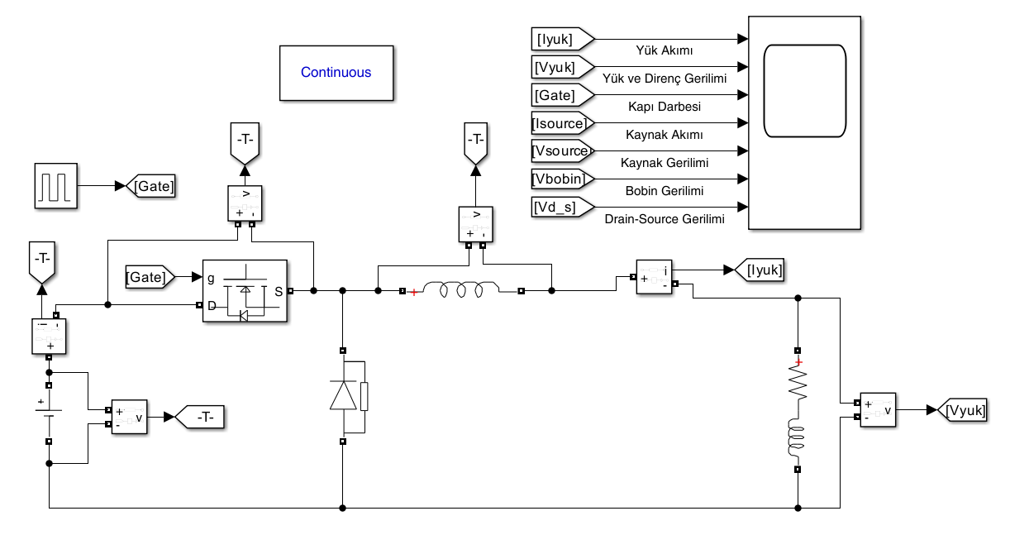
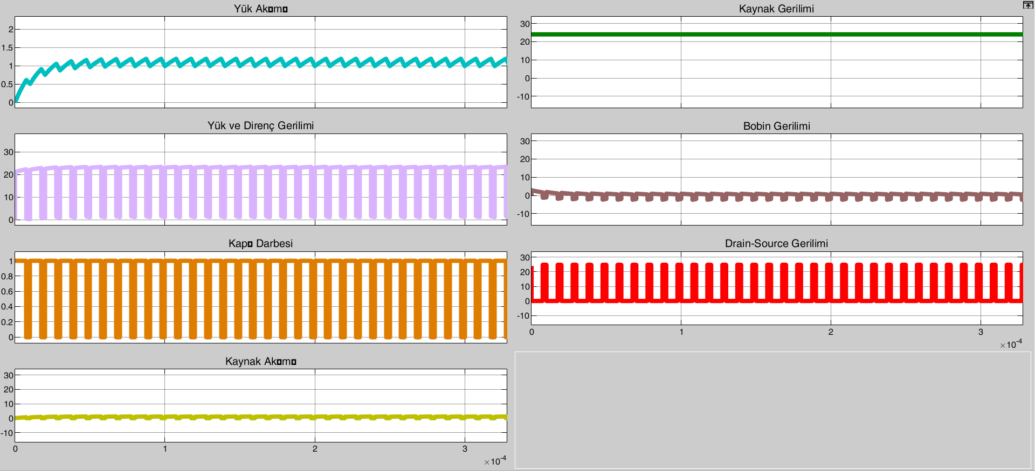

As can be seen in the simulated circuit, the obtained data is consistent with the calculations performed. Following the initial transient state at startup, the current and voltage outputs were obtained as intended.

QUESTION 2
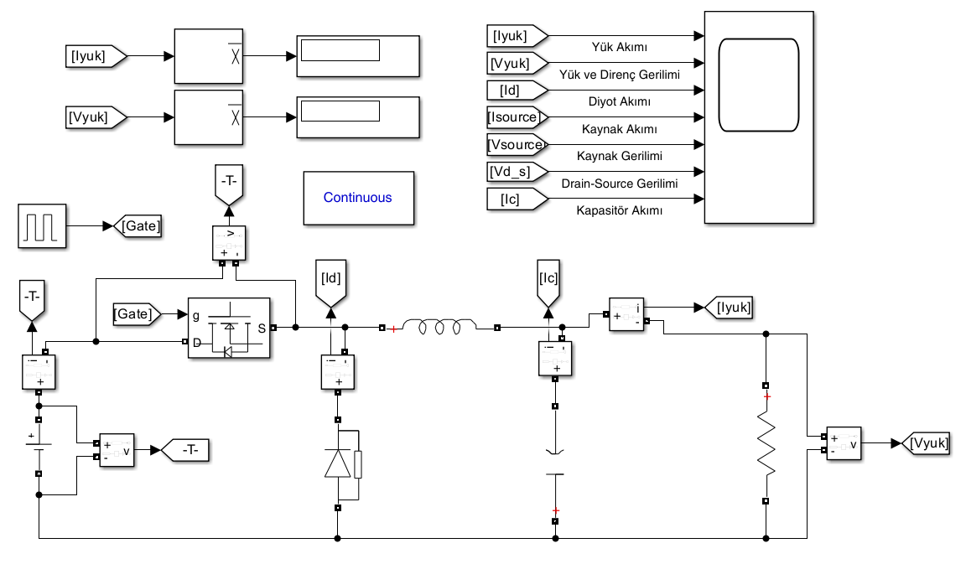
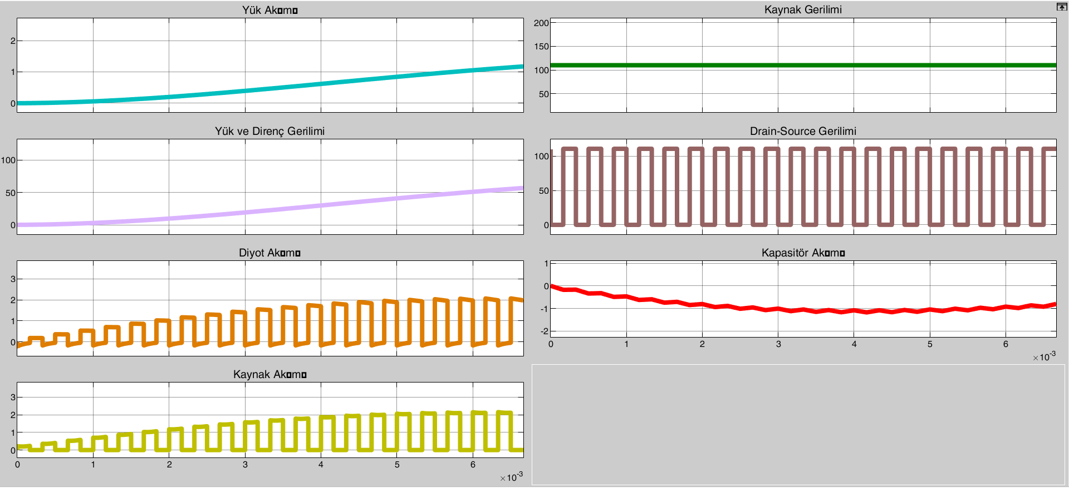

In this circuit, the low-pass filter ensures more stable operation by blocking frequencies above a certain threshold. By keeping the voltage within specific limits and preventing fluctuations, it allows the output voltage to be maintained at the desired level in a more constant manner. Comparing the first and second questions as seen from the waveforms the primary function of low-pass filter circuits is to minimize output voltage ripple and provide a more stable (steady-state) output.

